# PROJECT OBJECTIVES

Project Objectives

# A New Hint to Transportation-Analysis of the NYC Bike Share System

|  |  |
| --- | --- |
| Date | 04 November, 2022 |
| Team ID | PNT2022TMID22202 |
| Team Lead | Santhosh kumar V |
| Team Members | Sharan R  Yogesh S  Yuvaganesh GK |
| Project Name | A New Hint to Transportation- Analysis of the NYC Bike Share System |
| Maximum Marks | 8 Marks |

* The project mainly focuses on the analyses New York City’s Citi-Bike share system to understand the spatial design considerations as well as usage patterns that emerge from this analysis.
* The Citi-bike trip data set was a massive in size containing over a million observations per month. So, in order to better understand data set for generating useful visualizations for developing more relevant insight about the system, a set of descriptive statistics were generated.
* It's important to provide better data visualizations and reduce the complexity of the dataset so for that we use IBM Cognos Analytics and explain the requirements using this projects.

# GOAL OF THE PROJECT

* + The final goal is to use this analysis as the basis for developing CO2e emission numbers normalized by passenger kilometer travelled (PKT) for a bike share program so that it may be compared to other modes of transportation.

# Technical Architecture:

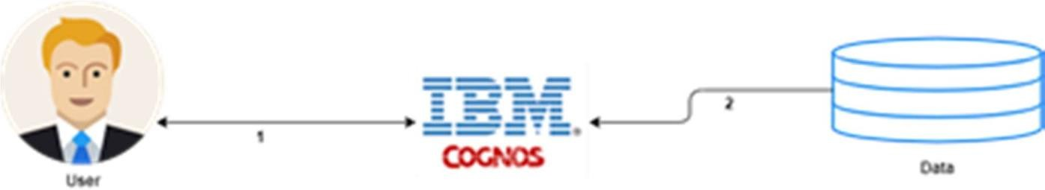

* + - Project Flow Users create multiple analytical graphs/charts/Visualizations.
    - Using the Analytical Visualizations, build the required Dashboard(s).
    - Saving and visualizing the final dashboard in the IBM Cognos Analytics.